Project 1 Part 3

Kunpeng Liu (kl3070) Zichen Pan (zp2197)

1. URL

（每次重启VM那个IP都会变，所以明天问完TA看是不是一直要开着VM，最后一次开VM的时候再填）

2. Github

3. Changes to Schema

(1) We delete the ‘own’ relationship between Customers and Coupons because it is a redundancy relationship and it can be selected through SQL by the rest of entities. Thus we delete the ‘customer_id’ column from table ‘Coupons’.

(2) We modify the definition of ‘one product’ from single product to a bunch of same products for convenience and being practical. Thus we add attribute ‘quantity’ to table ‘Products’ to represent the number of products left in the inventory.

Due to the redefinition of ‘one products’, we renamed the ‘carts’ entity to ‘orders’ for convenience and the relationship between ‘orders’ and ‘customers’ changes: a customer could own multiple orders while an order can only belong to one customer. Thus we delete the ‘cart_id’ column from table ‘Customers’.

Also, the relationship between ‘orders’ and ‘products’ changes to many-to-many. Thus we eliminate ‘cart_id’ column in table ‘Products’ and add a new table: ‘Orders_Products’. The schema of this new table is shown as below:

Orders_Products(product_id, order_id, quantity)

Note that the ‘quantity’ column in ‘Orders_Products’ represents the quantity of this product in this order.

The final ER-diagram and schema is shown as follows:

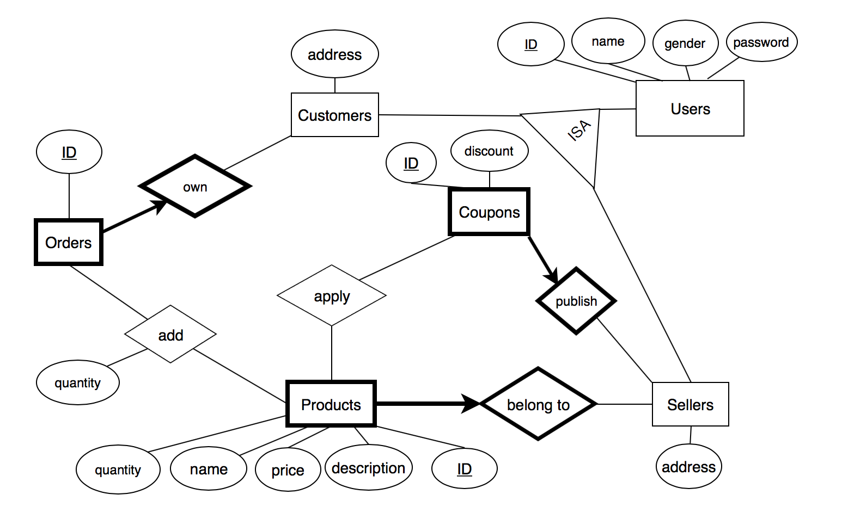

Tables:

users (user_id, name, gender, password)

customers (user_id, address)

sellers (user_id, address)

products (product_id, name, description, seller_id, price, quantity)

coupons (coupon_id, discount, seller_id)

orders (order_id, customer_id)

coupon_applied (coupon_id, product_id)

orders_products (order_id, product_id, quantity)